Name: __________________________________________________________________________
Putting it All Together! Day 2 Warm-Up

Directions: If it is not indicated, round to the nearest thousandth.
Find the surface area and volume of the composite figure. Show all work and label answers.
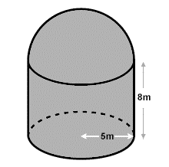
Surface Area_____________

Volume_________________

2.

You will not put fabric under the ottoman.

3. The tent is made of a material that costs $5.22 per square foot. The material for the triangular faces and the two exposed sides is different than that of the material of the bottom of the tent. Find the cost of material needed for just the exposed part of the tent.

