**Rectangle Homework**   
**Properties of Rectangles – a parallelogram with four right angles.**

* Opposite sides of a parallelogram are congruent
* Opposite angles of a parallelogram are congruent
* Consecutive angles of a parallelogram are supplementary
* The sum of the angles of a parallelogram are 
* The diagonals of a parallelogram bisect each other
* The diagonals are congruent

1. If m<HFG= 74ᵒ, fill in all of the other angle measures, if FGHI is a rectangle.

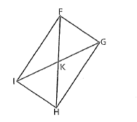

**1**

**9**

**10**

**3**

**2**

**8**

**4**

**5**

**6**

**7**

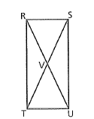

2. If m<RTV= 150ᵒ, fill in all of the other angle measure if RSTU is a rectangle .

**10**

**9**

**2**

**3**

**1**

**4**

**5**

**7**

**6**

**8**

3. Use rectangle RSTU and state the property you used.

a.) If TR = 3x + 8 and US= 6x – 28. Find x, US and SQ.

 x = __________

US = _________

SQ = ________

b.) If m<SUR = 3x + 6 and m<SUT = 5x – 4. Find x and m<SUT.



4. Use rectangle ABCD and state the property you used.

a.) If EB = 5x - 8 and DE = 4x - 1. Find x, DE and BD.

x = __________

DE = _________

BD = ________

5. Determine whether the figure with vertices F(-4,-3),G(3,-1), H(2,3) and J(-5,1) is a rectangle.

