Reflections Homework
- Reflect the figures below across the indicated line of reflection.
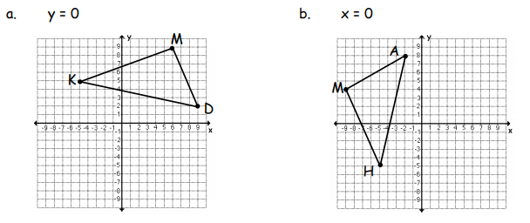
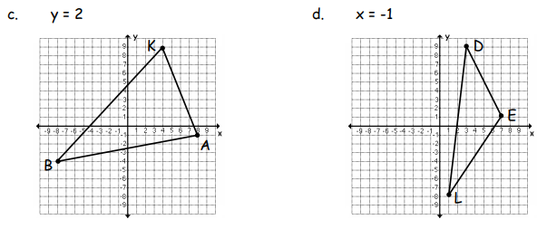

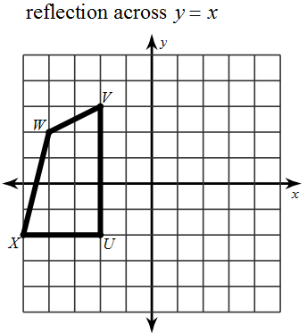
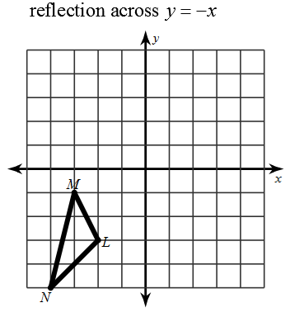
e. f.

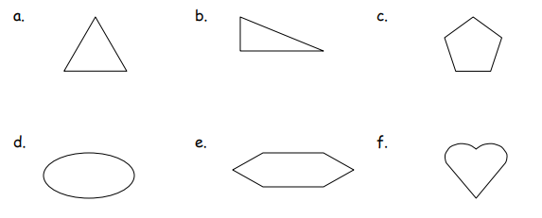
- Draw in all lines of symmetry and state the number of lines of symmetry the figure has. If the figure does not have any lines of symmetry, write “none.”

- Which image is a reflection of the original?

- Which image is a reflection of the original?

