8.1-8.5 Reviewing: Pythagorean Theorem, Special Right Triangles & Trigonometry
Directions: Complete the following questions.

1. A ladder leaning against a house creates an angle of elevation of 60°. The foot of the ladder is 7 feet from the foundation of the house. How long is the ladder? | 2. A ladder leaning against a house creates an angle of elevation of 22°. The foot of the ladder is 7 feet from the foundation of the house. How long is the ladder? | 3. A ladder leaning against a house. The foot of the ladder is 7 feet from the foundation of the house and 24 feet up the wall. How long is the ladder?

4. a. Determine the height of the b. Determine the height of the flagpole
flagpole shown in the figure. shown in the figure.
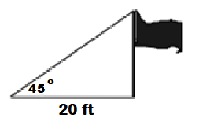

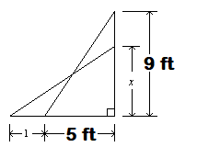
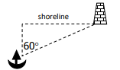  5. At a point 500 miles north of a ship, the shoreline runs east and west. West of that point, the navigator sights a light house at an angle of 60° . How far is the ship from the lighthouse?  7. A person hang gliding at an altitude of 300 feet is over a spot 2,250 feet from an area of soft grass where he would like to land. At what angle of depression should he see the grass?  9. Find all trig ratios for <A and <C.  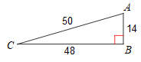 |  | 6. A boy flying a kite lets out 100 feet of string making an angle of elevation of 40°. How high above the ground is the kite?  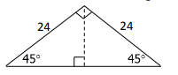  8. The roof of a house is the shape of an isosceles right triangle. The slope of the roof is 24 feet, what is the height of the roof?  10. An electrician sets up a ladder to reach the top of an electric pole 9 feet above the ground. The base of the ladder is 5 feet from the pole. While the electrician is gathering tools, the foot of the ladder slides 1 foot farther from the pole. How far up the pole does the ladder reach? Use exact values
11. David must install fencing around a lot that is shaped like a right triangle. The side of the lot that runs east-west is 200 ft long. The side of the lot that runs north-south is 125 ft long. Calculate how many feet of fencing he will need to surround the entire lot.  13. An ornamental pin is in the shape of an equilateral triangle. The length of each side is 6 centimeters. Josh will attach the fastener to the back along AB. Will the fastener fit if it is 4 centimeters long?  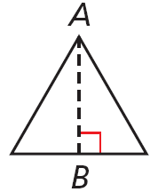  15. A person is standing on the third floor of the Galleria and has an angle of depression of 22° to the edge of the ice skating rink. The rink starts under the person and is 110 feet long. How high is the person to the nearest foot.  17. Find all trig ratios for <A and <C.  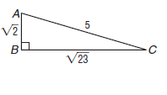  19. Find x and y.  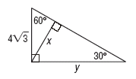  21. Find the length of AB in this trapezoid.  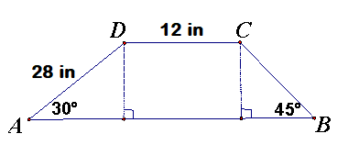 | 12. Jana is cutting a square of material for a tablecloth. The table’s diagonal is 36 inches. She wants the diagonal of the tablecloth to be an extra 10 inches so it will hang over the edges of the table. What size square should Jana cut to make the tablecloth?  14. The angle of elevation of a 110 foot crane is 45°. How high can the crane raise building material?  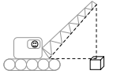  16. Does lengths 8, 15, 17 form a right, acute or obtuse triangle? If it forms a right triangle is are the lengths Pythagorean Triples?  18. A ball is rolling down a hill that is 424 feet long and has a height of 38 feet. What is the angle of depression for the hill?  20. Find x and y.  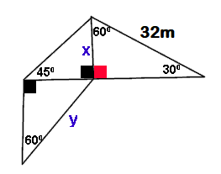  22. Find x.  