Name: _____________________________________________Hour: _______
Basic Surface Area and Volume of CONES
Homework
Find the volume and surface area of the solid. Round to the nearest tenth.

1.

2.

3.

4.

5.

6. Use the cone below to find the radius if the volume is 523.6 in³.

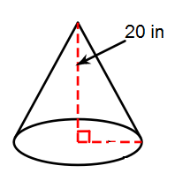

7. Find the slant height of the cone below if the surface area is
90πcm².
