Name: _______________________________________________________Hour: ___________________
Basic Surface Area and Volume of Prisms Homework 2017
Directions: Find the volume and surface area of the solid, round to the nearest tenth if needed.
1.
SA= _______________

V = ________________

2.

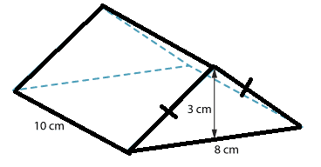

3.

4.

5.

6. How many square feet of cardboard does Jessica need to make a rectangular prism with length of 16 inches, width of 9 inches, and height of 4 inches? Draw this 1st.

7. A package shaped like a cube has an edge that is 28 cm long. How much space is available to pack inside the box? Draw this 1st.

8. Given the volume of the triangular prism is 42 ft³, find the height of the prism.
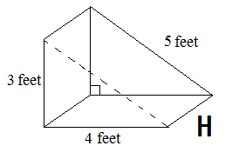

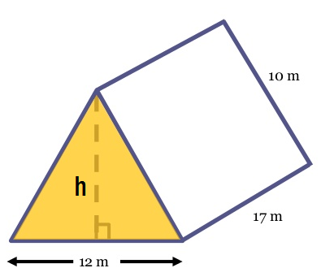
9. Given the surface area of the triangular prism is 640 m², find the missing part.

10. Draw the net, then find the volume and surface area of the solid, round to the nearest tenth if needed.

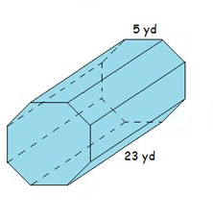
11. Draw the net, then find the volume and surface area of the solid, round to the nearest tenth if needed.

