Acc Geometry
Expanding on Vectors- Notes Day 2

Physics Supplement

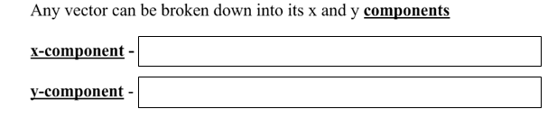

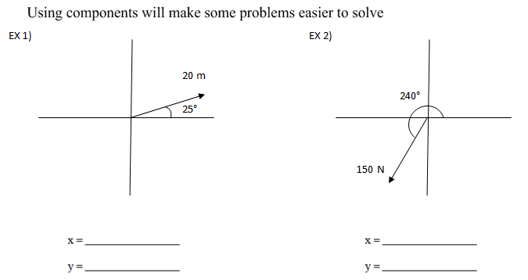

Real World Application

Ex3). Sketch a N 25º E Vector Ex4). Sketch a W 50º S Vector

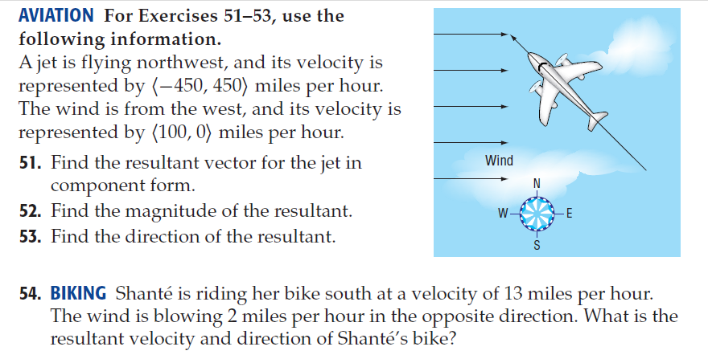

Accelerated Geometry Name: ______________________________
Vectors Day2 Practice

- Suppose a pilot begins a flight along a path due north flying at 250 miles per hour. If the wind is blowing due east at 20 mph, what is the resultant velocity and direction of the plane?

- Suppose a person is canoeing due east across a river at 4mph.
  - If the river is flowing south at 3 mph, what are the resultant direction and speed of the canoe?

  - If the current reduces to half of its original speed, what are the resultant direction and speed of the canoe?

- A freighter has to go around an oil spill in the Pacific Ocean. The captain sails due west for 30 miles. Then he turns the ship and heads due south for 25 miles. What is the distance and direction of the ship from its original point of course correction?

- Suppose a section of the Minnesota River has a current of 2.5 mph. If a swimmer can swim at a rate of 5 mph, how does the current affect the speed and direction of the swimmer as she tries to swim directly across the river?

- A jet is flying northwest and its velocity is represented by < -400, 400 > mph. The wind is from the west, and its velocity is represented by < 50, 0 > mph.
  - Find the resultant vector for the jet in component form.

  - Find the magnitude of the resultant.

  - Find the direction of the resultant.

- Stacey is riding her bike south at a velocity of 15 mph. The wind is blowing 4 mph in the opposite direction. What is the resultant velocity and direction of Stacey’s bike?

- The vector v represents the speed and direction that the wind is blowing. Suddenly the wind picks up and doubles its speed, but the direction does not change. Write an expression for a vector that describes the new wind velocity in terms of v.

- Beth has a square with coordinates (-3, 2), (-4, 3), (-3, 4) and (-2, 3). She wants to move it to another place using a translation by the vector v = < 7, -5 >. What are the coordinates of the new image?

- Jan is swimming in a triathlon event. When the ocean water is still, her velocity can be represented by the vector < 2, 1 > mph. During the competition, there was a fierce current represented by the vector < -1, -1 > mph. What vector represents Jan’s velocity during the race?

Find the magnitude and direction of each resultant for the given vectors.
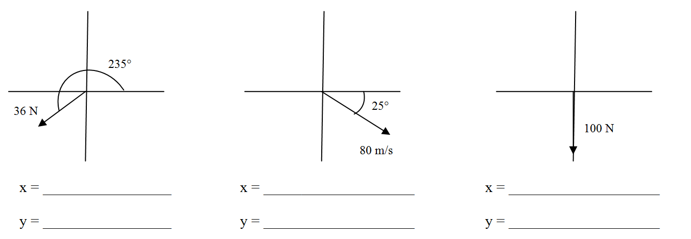
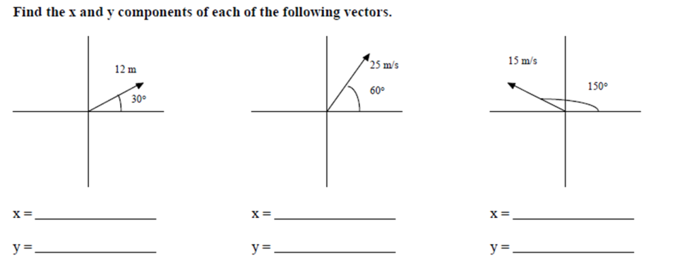
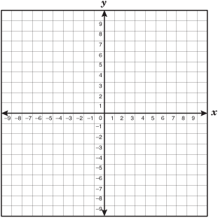
10. 11.

