Notes – Sector Area & Arc Length | Name: | Th
Standard: | Hour:

Objective: I know how to calculate arc length and sector area.
Given arc length or sector area, I can find the radius, central angle, total area or circumference.

Review & Connect
Sectors and Arc Length
Circumference of a Circle  $$C=2πr$$  Find the length of arc AB.  A  B  A  5cm  A  B  7cm  - Diameter 12m.  B  120º  - Complete the formula for arc length  $$L=\frac{ }{}∙$$  - Find the arc length of a 288º central angle and a radius of 15. | Area of a Circle  $$A={πr}^{2}$$  Find the area of each sector (shaded region).  5cm  A  B  A  14cm  A  B  B  6cm  120º  - Write a formula for sector area.  $$S=\frac{ }{}∙$$  - Find the area of a 288º sector with a radius of 15.

Examples
Find each indicated value. Show ALL work! Give answers as an exact value (fractions and in terms of pi).
- Find the area of the sector | - Find the area of the sector.
- Find the area of the shaded sectors. Radius = 24  50ᵒ  40ᵒ | - Find the area of the circle if a sector has a central angle of 90ᵒ and an area of $27π$ km².  $$3π$$
- Find the radius of the circle if a sector has a central angle of 240ᵒ and a sector area of 150π km². | - The length of minor arc AB is $3π$ and measures 45$°$.  a) What is the circumference of the circle?  b) What is the measure of the radius of the circle?  c) What is the area of the sector AOB?

Hmwk – Sectors Area & Arc Length Name: ______________________________
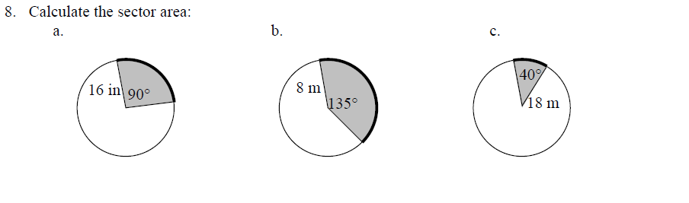
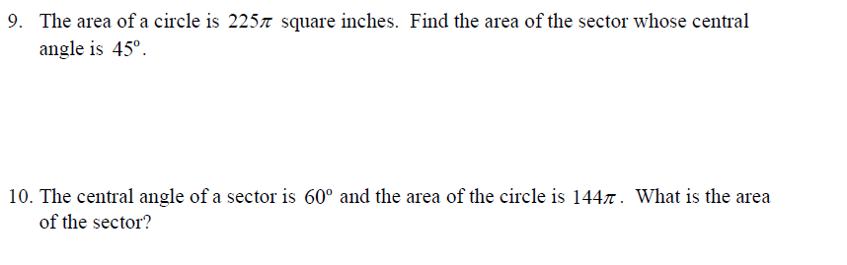

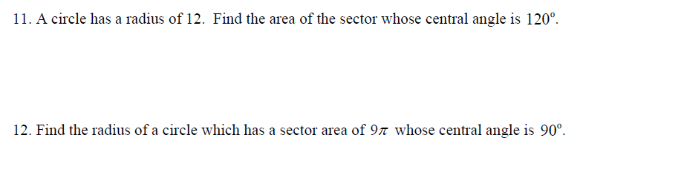
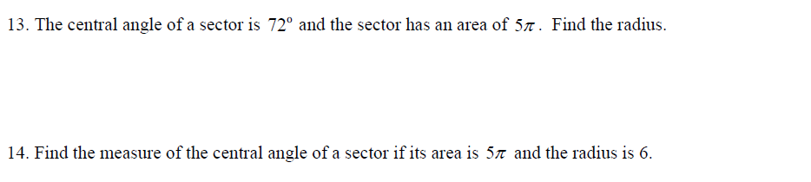
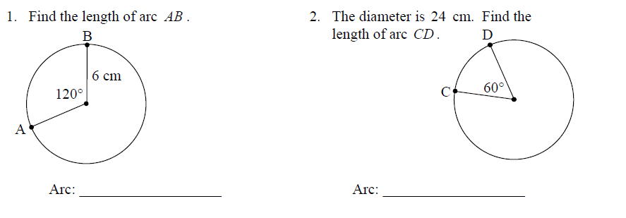
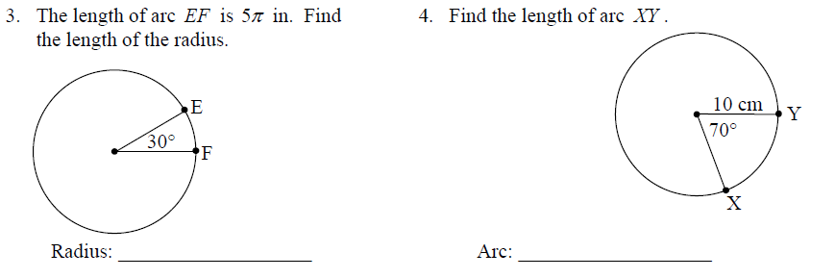
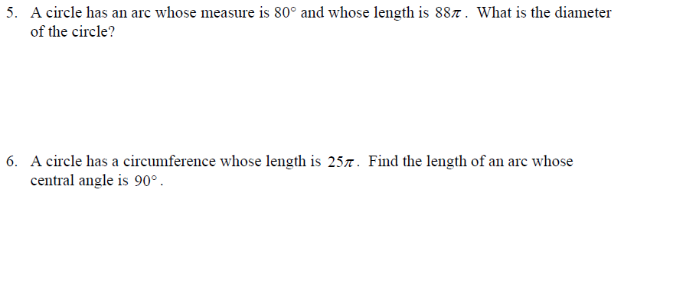

- Minor arc AB has an arc length of 8π ft and a measure of 60$°$.  - What is the total circumference?  - What is the length of the radius?  - What is the area of sector AOB? | $$8π$$
16. Sector AOB has an area of 16π mi² and a central angle of 40$°$  - What is the total area?  - What is the length of the radius?  - What is the length of minor arc AB? | $$16π$$

