Similarity Quiz Review

1. Given ∆ABC~∆DBE. If the perimeter of ABC is 108m and the perimeter of triangle DBE is 24m, find all variables.

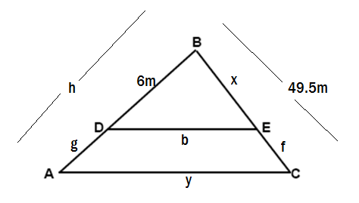

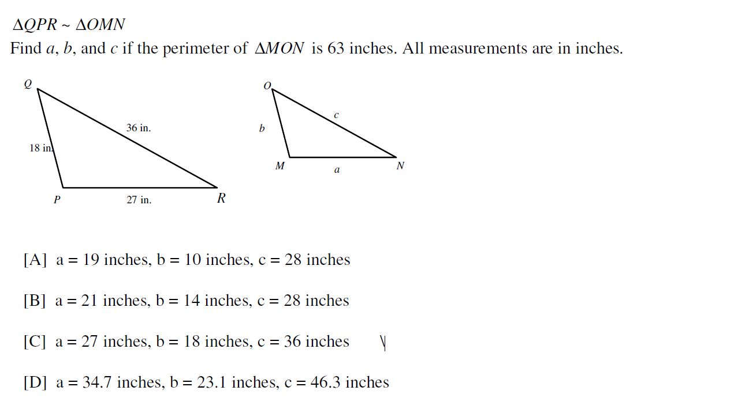

2.

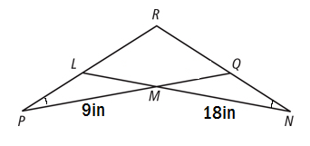3. Find w if $RM = 7w+5 and RP = 4w-1$. Show all work and show what two triangles are similar… and why!

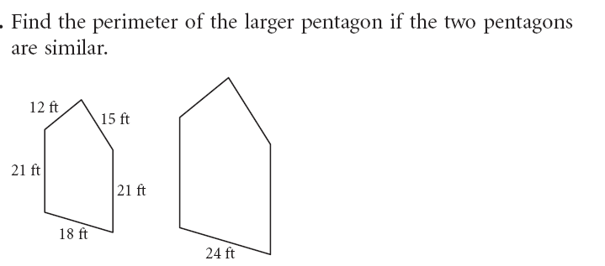4.

5. **a). Explain why $∆CAT\sim ∆DAG$. b). What is the measurement of CD?**

C

T

48

12

16

D

G

A

**6.** Anna wants to find the height of the tallest building in her city. She stands 384 feet away from the building. There is a tree 200 feet in front of a building that is 20 feet tall. How tall is the building to the nearest foot? **SHOW ALL YOUR WORK.**



**7.** A flagpole that is 11 feet tall casts a 5 and a half foot shadow. At the same time of day, a nearby building casts a 10 ft, 7 in shadow. How tall is the building?

8. The following polygons are similar.

A. Write the similarity statement.

B. find x..

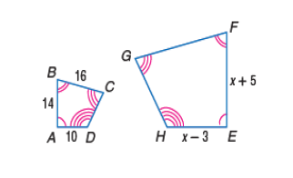

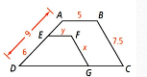**9. Find the value of x and y.**

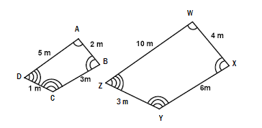**10. Are the following polygons similar? Explain/show why or why not.**

[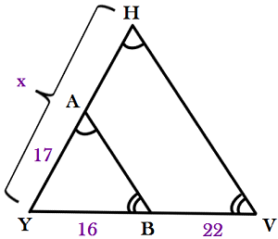](http://www.google.com/url?sa=i&rct=j&q=&esrc=s&source=images&cd=&cad=rja&uact=8&ved=0ahUKEwiumfDR67vXAhWP0YMKHWDGD-4QjRwIBw&url=http%3A%2F%2Fstudy.com%2Facademy%2Fpractice%2Fquiz-worksheet-applications-of-similar-triangles.html&psig=AOvVaw2jk-EWq3DeORVzfq3Rar0J&ust=1510672450710517)**11. Find x.**

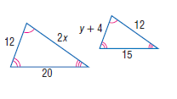**12. a. State the similarity statement. b. Find the SLR (Scale Factor). c. Find x and y.**

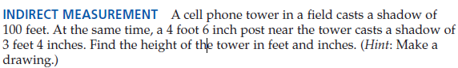

**13.**

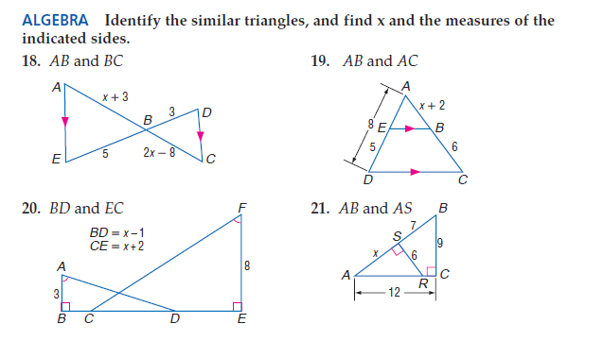**14. Identify the similar triangles, find the SLR, find x, and the indicated sides.**

**15. Identify the similar triangles, find the SLR, find x, and the indicated sides.**



**16. Identify the similar triangles, find the SLR, find x, and the indicated sides.**



**17. Identify the similar triangles, find the SLR, find x, and the indicated sides.**



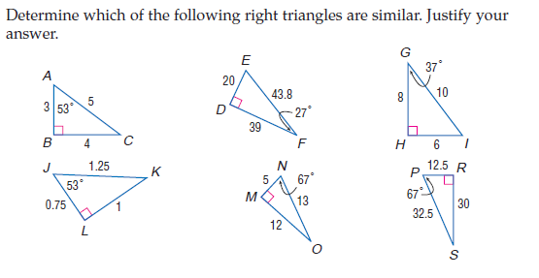**18.**

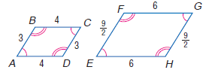**19. Are the following polygons similar? Explain/show why or why not.**

**20.** Nicole wants to find out the height of her favorite pine tree so that she can fit it in her house for Christmas. She stands within the tree’s shadow and walks until her shadow meets the trees shadow. Nicole is 152.4cm tall. Her feet are 91.44cm from the base of the tree. She also knows that the tree has a shadow of 274.32cm long at this time of day. Help Nicole find the height of her favorite tree. If she can fit a 250cm tree in her living room, will this tree fit for the holidays? Explain. Please leave final answer in cm and round to the nearest hundredth.



Height of tree: _____________

Can she use the tree for Christmas? _______________

**Explain…..**