**13.1 Right Triangle Trigonometry**



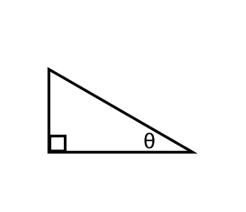

**Ex1** Find the 6 trigonometric ratios.

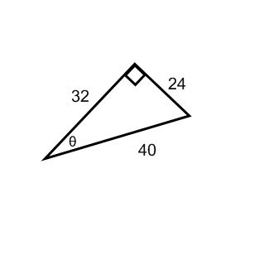

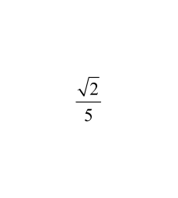**Ex 2** If tan A = , then find csc A.

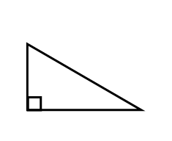

**Ex 3** Solve ΔRST. Round measures of sides to nearest tenth and angle measures to nearest degree.

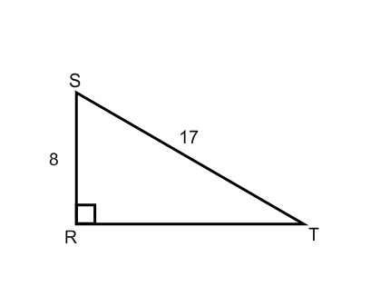

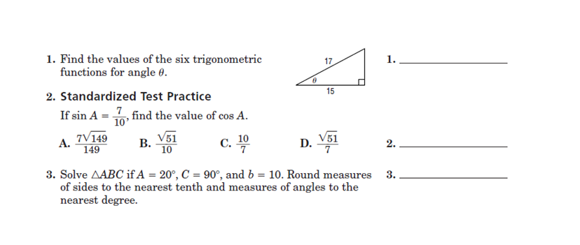HOMEWORK: