Name: ______________________
Vector Practice
Find the component form, magnitude and direction for $\overset{⃑}{MN}$.
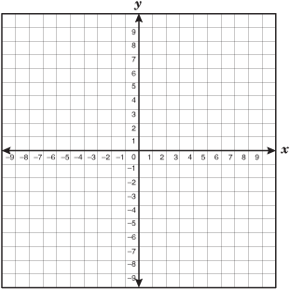
1. M(8,1) and N(2,5)
Component Form:

Magnitude:

Direction:

2. M(-1,7) and N(6,-8)
Component Form:

Magnitude:

Direction:

3. Find the magnitude and the direction of $\overset{⃑}{v}=<12,-9>$
Magnitude: Direction:

4. Find the magnitude and direction of the resultant vector given $\overset{⃑}{m}=〈-4,0〉$ and $\overset{⃑}{n}=〈7,-4〉$.

5. Find the magnitude and direction of the resultant vector given
$\overset{⃑}{m}=〈9,-10〉$ and $\overset{⃑}{n}=〈-10,-2〉$.

