Volume of Prisms and Pyramids Homework
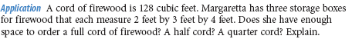
1.

2. Mount Rainier, which is an active volcano in Washington, is 4.392 km tall and about 18 km across its base. Assume that it can be modeled by a cone. Find the volume of rock it would take to fill Mt. Rainier.
3. The Great Pyramid of Khufu is a square pyramid. The lengths of the sides of the base are 755 feet. The original height was 481 feet. The current height is 449 feet. What volume of material has been lost?

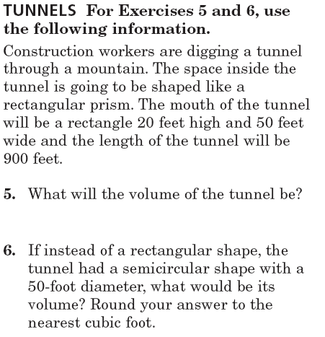
4.

Directions: Find the Surface Area and Volume of the following figures. Round to the nearest tenth.
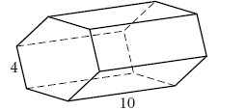
7. 8.

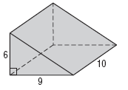
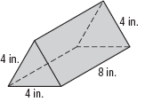
9. 10.

11. The volume of a triangular prism is 96m³. The prism has a right triangle base with legs of 8 meters and 6 meters. Find the height of the prism.

h

12. The volume of the rectangular pyramid has a volume of about 146.67 km³. The base of the pyramid is a rectangle that is 5 km by 8 km. Find the height of the pyramid.
h

13. The volume of a rectangular prism is 1152 cubic inches and the area of the base is 64 square inches. Find the height of the prism.

14. The surface area of the trapezoidal prism is 489.6 mi². Find the missing length below.

h

15. The volume of a triangular prism is 144 yd³. The prism has a right triangle base with legs of 8 meters and 6 meters. Find the height of the prism.
h

16. The volume of the rectangular pyramid has a volume of about 266.67 yd³. The base of the pyramid is a rectangle that is 10 km by 8 km. Find the height of the pyramid.
h

17. The volume of a rectangular pyramid is 84 in³ and the area of the base is 12 in². Find the height of the pyramid.

19. If a can is 12 cm tall and fits in the holder which has 1cm thickness,
what is the volume of the entire solid.

18.

20. 21.

Composite Figures Practice

Find the surface area and volume for the following solids. Round to the nearest tenth if needed.
22. 23. 24. 25.

26. 27.

28. 29.

