Practice Similar Solids & Volume- ACC Geometry

Examples: Find the missing dimension. Round to the nearest tenth.

1. The volume of a triangular prism is 96m³. The prism has a right triangle base with legs of 8 meters and 6 meters. Find the height of the prism.

h

2. The volume of the rectangular pyramid has a volume of about 146.67 km³. The base of the pyramid is a rectangle that is 5 km by 8 km. Find the height of the pyramid.
h

3. The volume of a cylinder is 616 cubic meters and the height is 4 meters. Find the length of the diameter of the cylinder.

4. The volume of a rectangular prism is 1152 cubic inches and the area of the base is 64 square inches. Find the height of the prism.

5. A formula for the volume,$V$, of a right cylinder is $V=πr^{2}h$, where $r$ is the radius and $h$ is the height. If a tanker truck has a tank as shown below with a diameter of $3$ meters and a length of $10$ meters and is filled with water. Find the weight of the tank, in pounds. (Note: $1$ cubic meter of water weighs approximately $2,205$ pounds.)

6. Find the amount of cake needed for this structure. Round to nearest tenth.

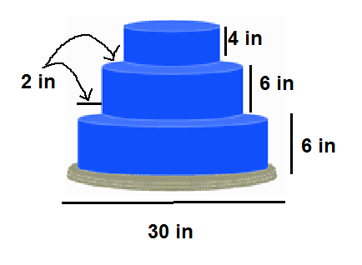

7. If the radius of a cylinder is r = 4xy⁶ and the height is h = 5x²y⁴ what is the expression which represents the volume of the cylinder in terms of x and y?

8. A large cube has edges that are twice as long as those of a small cube. The volume of the large cube is how many times the volume of the small cube?

9. In order to clean her aquarium (rectangular prism), Stephanie must remove half of the water. The aquarium measures $30$ inches long, $16$ inches wide, and $12$ inches deep. The aquarium is currently completely full. What volume of water, in cubic inches, must Stephanie remove?

10. Find the volume of the composite solid below. Round to the nearest tenth.
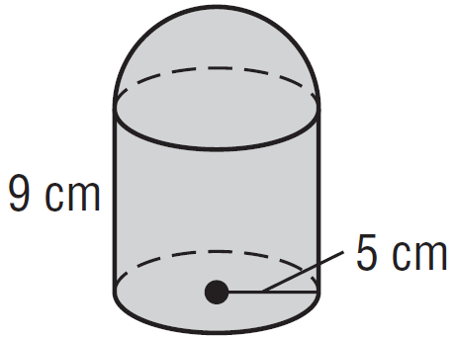

11. A sphere and a cone have the same radius. The height of the cone is 4 times the length of the radius which is a whole number greater than 2. Explain the relationships of the volumes by showing the expressions that represent the volumes, using r for the radius.

12. An ice cream cone is $8$ centimeters deep and has a diameter of $5$ centimeters. A spherical scoop of ice cream that is $5$ centimeters in diameter rests on the top of the cone. If all the ice cream melts into the cone, will the cone overflow? Explain. (Assume the liquid and solid state of the ice cream will stay the same per cubic centimeter).

13. The ratio of the radii of two spheres is 7:3. Find the volume ratio of the two solids then, use it to find the EXACT volume of the smaller sphere if the volume of the larger sphere is 4116π cubic feet.

14. A sphere has a volume of 4500π cubic inches. Find the diameter of the sphere.

15. You are selling your game day basket balls signed by Andre Drummond on EBay. You have offered free shipping to the highest bidder. To keep the cost at a minimum, you need to ship the basket balls in the proper skipping container. Find the amount of empty space within shipping containers. If you wanted to also send them a signed jersey, what packaging option would have the most empty space? Round each step to the nearest thousandth if necessary.
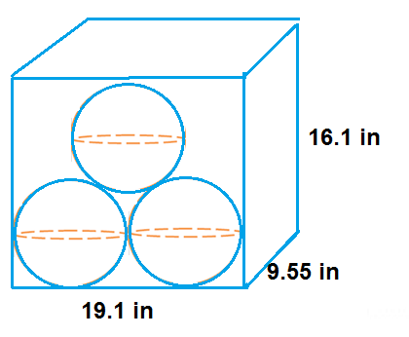

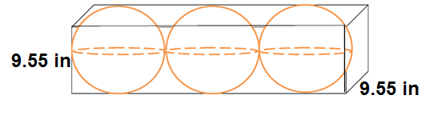

Option 1 Option 2

16. A cereal company decided to make an oddly shaped box for a promotion. Their new design is a rectangular prism with length 10 in., width 8in., and height 4 in. They plan to attach a cylinder with a radius of 2 in and the height of 10in. to the 8x10 face. How much will it take to fill up the odd box? Round to the nearest tenth.

17. Find the volume, using A = n*1/2* ab*Sin. Round to the nearest tenth.

