Name: _________________________________________________________

HW: Working Backwards: Surface Area & Volume of Cylinders, Cones, and Spheres

1. Find the radius of the cylinder below if the volume is 150$π$ in³
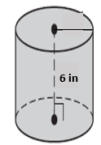

2. Find the diameter of a cylinder whose volume is 75π cm³ and its height is 5 cm.

3. Find the diameter of a sphere if the SA=576$π$mm².

4. Find the radius of a sphere if the V=288$π$ m³.

5. Use the cone below to find the radius if the volume is 540π in³.
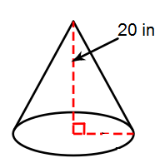

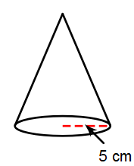
6. Find the slant height of the cone below if the surface area is 90πcm².

Directions: Identify each figure, find the surface area and volume of the following figures. You must write the formula you used first. Keep all answers in terms of pi, then show the rounded value to the nearest thousandth.
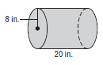
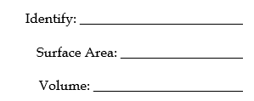
7.

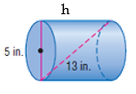
8.

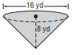
9.

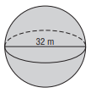
10.

